# NATURAL LANGUAGE PROCESSING

DSA 2023 Summer School

University of Rwanda

Kigali – Rwanda

Dr. Andrew Kipkebut

# **How to create account on Huggingface**

**Step 1: open huggingface.co/join**

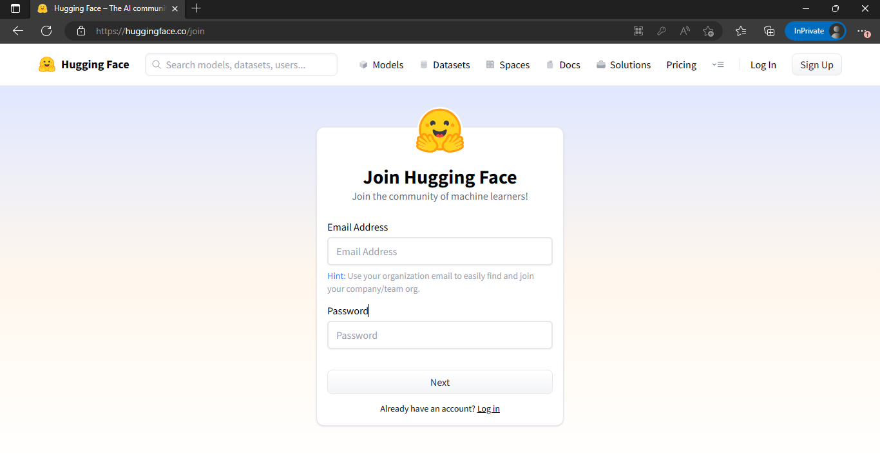

**Step 2: fill in your email and password and click Next**

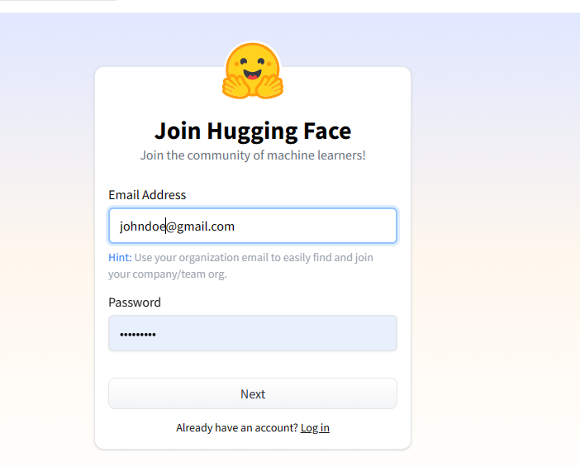

**Step 3: Complete your profile by filling your details and create account**

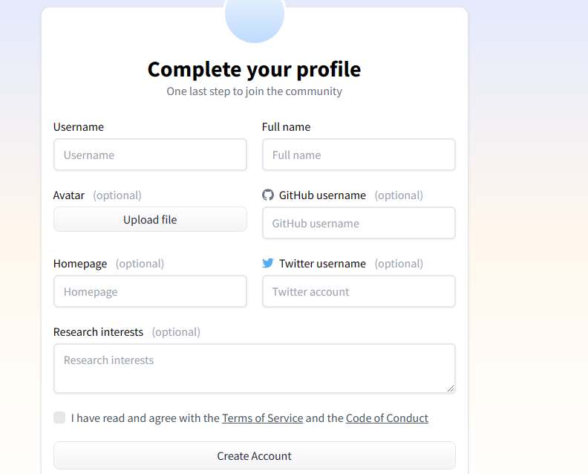

**How to get you access token**

**Step 1: open huggingface.co/settings/profile**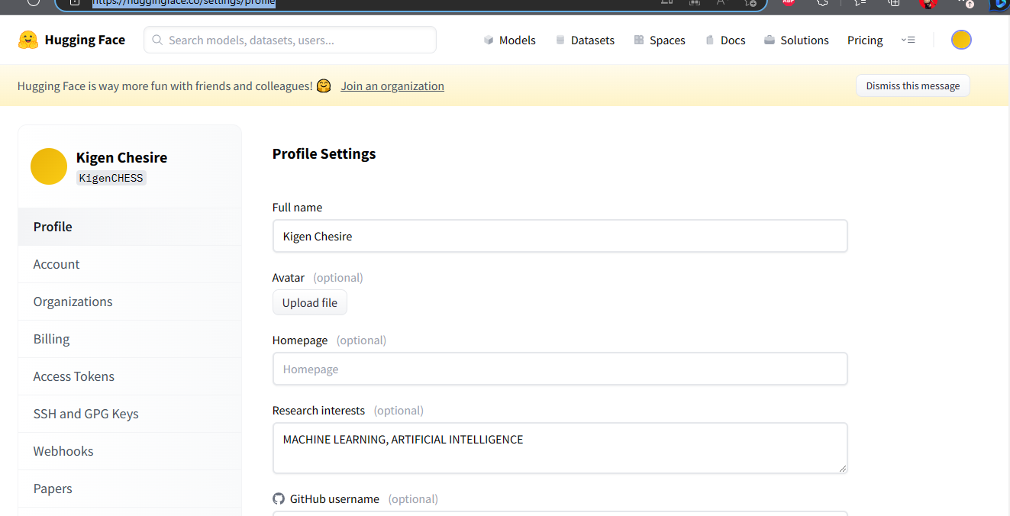

**Step 2: click on access tokens**

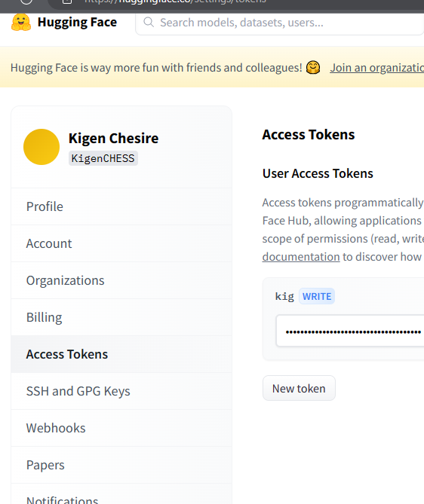

**Step 3: copy the access token**

